Progress Report – Shipley-Skinner Reserve-Riverside County Endowment
Research Project: Arthropods as the Missing Link to Understanding the Ecological Impact of an Invasive Plant, Brassica tournefortii
P.I.: M. P. Daugherty, Department of Entomology, University of California,
Riverside, CA 92521; matt.daugherty@ucr.edu; 951-827-2246
Funding Year: 2014

Our 2014 proposal to the UCR Center for Conservation Biology had two aims: 1) determine the community-wide impact of an invasive plant, Brassica tournefortii, in southern California desert ecosystems; 2) determine the impact of invader-invader interactions on native species using a three-species model system comprised of Brassica tournefortii (invasive plant), Bagrada hilaris (invasive insect herbivore), and Atriplex canescens (native plant). We proposed a suite of observational and experimental studies to elucidate interactions among native and invasive plants and insects, and the respective impacts.

Field Studies
A suite of observational studies at the Oasis de Los Osos UC Natural Reserve was initiated in August 2013, with the aim of identifying mechanisms of Brassica tournefortii impact on native organisms. Twelve 32 m transects have been established, ~100 m apart, perpendicular and adjacent to a perennial stream (see Figs. 1 and 2). Transects encompass a plant community ecotone, transitioning from Encelia farinosa dominated rocky north-east facing slope to a Larrea tridentata dominated stabilized sand field. Br. tournefortii has been historically more abundant in “lower” transects within the Larrea tridentata dominated region.
Plant and arthropod communities present at each transect have been monitored since November 2013. During the 2013-2014 annual plant growing season, 14 surveys were conducted. Thus far during the 2014-2015 season, 3 surveys have been conducted and 2 more are planned. All plants were identified to species, and all insects to order or family (insect identification to family level is anticipated to be completed by May 2015 for all samples collected in 2013-2014). Temperature and humidity data have been recorded on site using iButton devices.
Preliminary Results (2013-2014)
A total of 30 arthropod orders have been detected among more than 20,000 specimens. A total of 31 plant species were detected within sampling plots, 27 of which are native and 4 non-native (including Brassica tournefortii). Indeed, while order-level richness appears to decline with increasing cover of Brassica tournefortii (see Fig. 3) arthropod abundance shows a weakly increasing trend with increasing cover of Brassica tournefortii (see Fig. 4).
Fig. 1: Map indicating location of 12 transects described above within the Oasis de Los Osos UC Natural Reserve within southern California. Red balloons indicate transects described above.
Fig. 2: Map indicating location of Oasis de Los Osos UC Natural Reserve within southern California. Red balloons indicate transects described above.

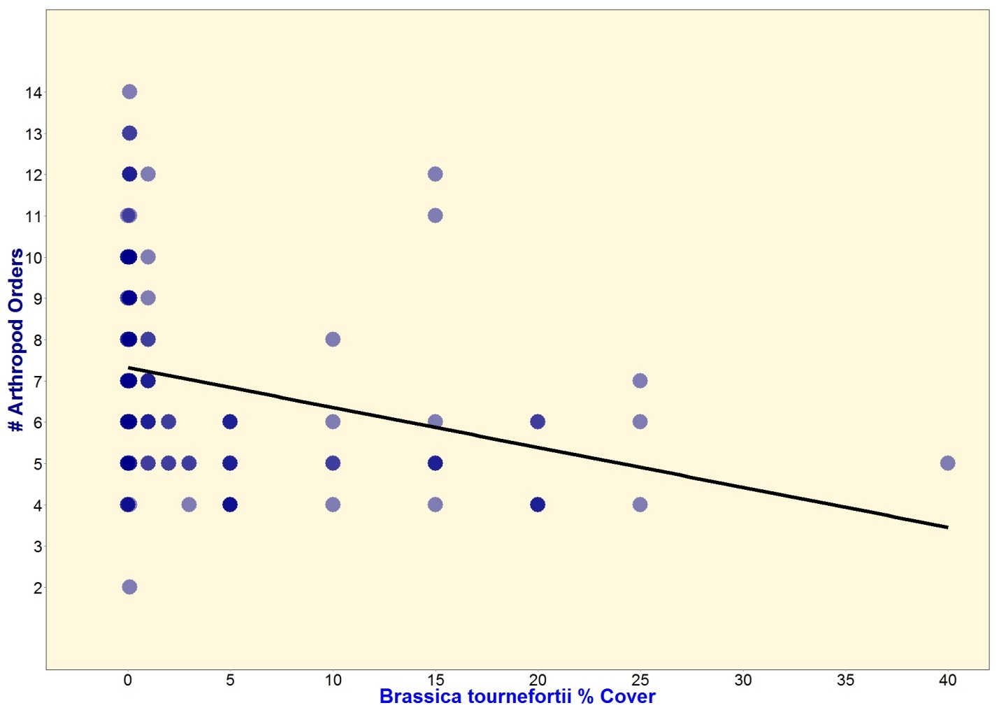
Fig. 3: The total number of arthropod orders collected via pan and pitfall traps in plots with increasing cover of the invasive non-native plant Brassica tournefortii.
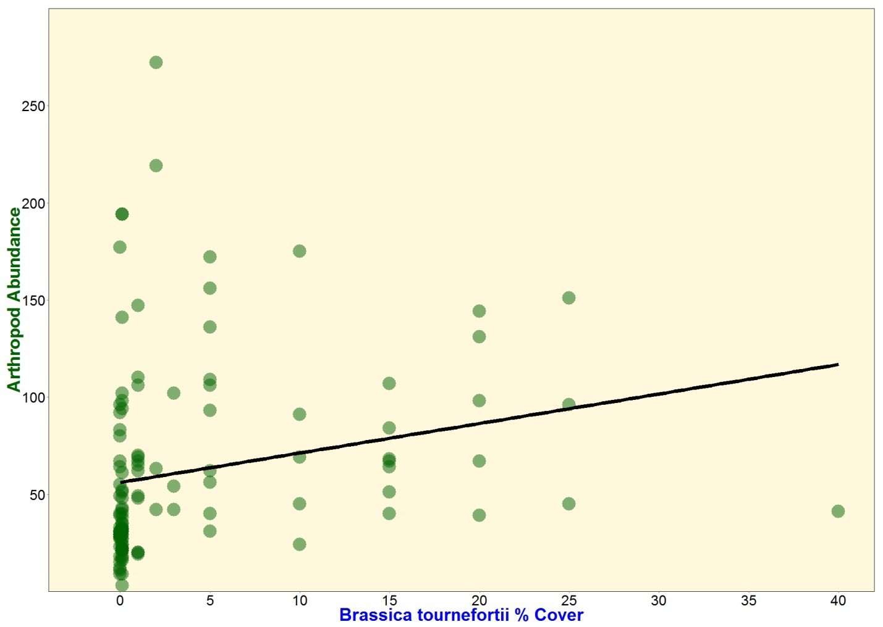
Fig. 4: The total abundance of arthropods collected via pan and pitfall traps in plots with increasing cover of the invasive non-native plant, Brassica tournefortii.

Field Cage Experiment
A total of 48 cages (5.8m³) have been erected on a field at UCR’s Agricultural Operations. Each cage is individually automatically irrigated. Within each cage is planted a single Atriplex canescens and one of three Brassica tournefortii treatments: 0 individuals, 10 individuals, 100 individuals. Bagrada hilaris have been reared in a greenhouse colony to attain individuals necessary to stock 24 cages with initial populations. Bagrada hilaris (5 male and 5 female individuals) have been released into each appropriate cage. This experiment is ongoing, and we look forward to sharing exciting results in the future.
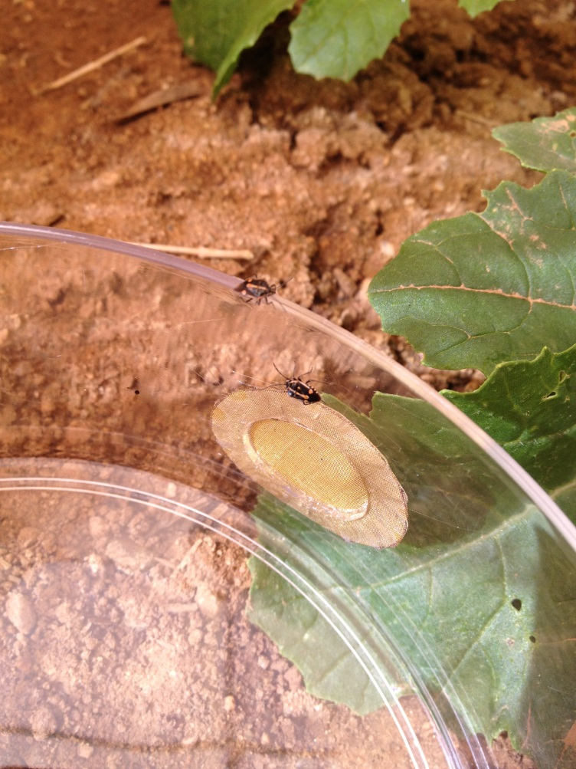
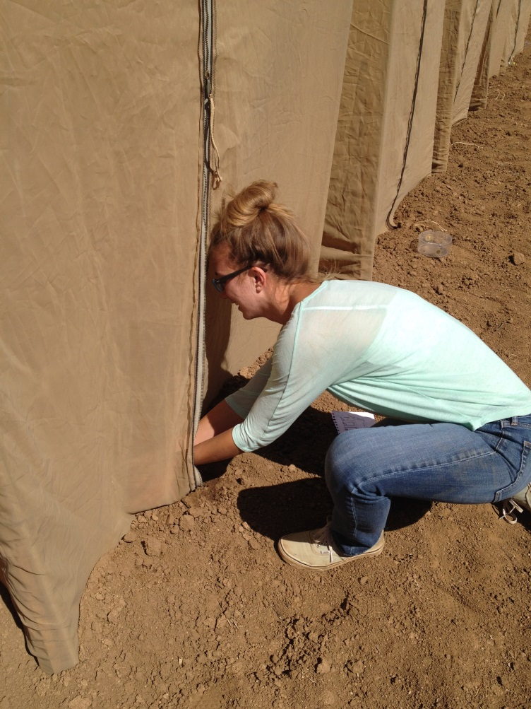
Fig. 5: Sarah O’Neill releasing Bagrada hilaris into experimental field cages at UCR Agricultural Operations.

