Effects of community type conversion on root development and water status
Michala Phillips
Introduction
Successful invasion of terrestrial ecosystems by exotic annual grasses causes a shift in community and ecosystem processes. The mechanisms promoting and maintaining type conversion are still being uncovered. One highly underrepresented avenue of study is the role belowground phenological differences and implication of these differences between natives and invasive. In recent years, research in invasion ecology has utilized both phenological (Willis et al. 2010) and belowground (Smith et al. 2014; Wilson 2014; D’Antonio & Vitousek 1992) approaches, yet there has been a lack of an integrative approach between the two. While coupling phenology and belowground studies will be extremely useful in invasion studies, there is also a lack of research on the belowground phenology on its own (Wilson 2014). The paucity of studies on belowground phenology stems from the inherent challenges present in belowground research.
Of particular importance, little is known about how root and hyphal production relates to soil water status between different vegetation types. In addition, the relationship of shoot phenology with root phenology is poorly studied across vegetation types. Research is finding that in contrast to previous assumptions, root and shoot phenology is often decoupled, with root production happening later in the growing season than leaf production. However, this likely varies with vegetation type (Steinaker & Wilson 2008). Older root:shoot growth models (Drew & Ledig 1980; Thornley 1971) argued for functional equilibrium. Functional equilibrium means that if one of the two plant subsystems (root and shoot) outgrows the other, the result will be suspension of growth of the one subsystem until they are balanced (Drew & Ledig 1980). This concept is rather straightforward, but may not be entirely accurate yet it does provide a framework that allows for growth to be decoupled. In some cases, shoots may be dependent on roots for photosynthates allowing for growth. While in other cases, nutrients stored in aboveground tissue may be all that is required for photosynthesis, even in the absence of concomitant nutrient uptake because the atmosphere warms more rapidly than the soil. (Steinaker et al. 2009). However, the are some studies (Du & Fang 2014; Steinaker & Wilson 2008; Steinaker et al. 2009) suggesting that the observed lag in soil warming may only be the chief driver of decoupled root-shoot phenology in boreal regions or regions with a harsh winter, making it unlikely that this will be the chief diver in more temperate or Mediterranean regions where seasonal temperature fluctuation are less severe.
Chaparral, a Mediterranean vegetation type, was previously thought to be resilient to disturbance, yet has recently undergone significant invasion (Meng et al. 2014; Dickens & Allen 2014; Stylinski & Allen 1999). The shift from evergreen chaparral shrubs to invasive grassland will have cascading effects on ecosystem services. Invasive species often have life history traits with flexible resource acquisition strategies (Ashbacher & Cleland 2015). Invasive annual grasses are drought escapers that may have short-lifespan, and fine roots for rapid nutrient uptake. Alternatively, drought tolerant shrubs are highly dependent on seasonal precipitation events for recharge through the soil profile (Schwinning & Ehleringer 2001), and are likely to possess long-lived relatively less efficient fine roots (Chen & Brassard 2013). In many arid systems, drought tolerant shrubs engage in hydraulic redistribution (the movement of water from wetter to drier regions of soil) during winter rain events to maintain existing plant physiological function and foliage throughout the summer drought (Ryel et al. 2004). This mechanism may also allow chaparral shrubs to decrease water available to shallow-rooted invasive annuals or short-lived perennials (Ryel et al. 2004). Differences in soil water infiltration may be driven by differences in resource acquisition strategies linked to life history traits. To this end, flexible responses to temperature or precipitation could make invasive species stronger competitors in a changing climate when compared to natives (Willis et al. 2010).
Site Description
The study was conducted in the San Gabriel Mountains at San Dimas Experimental Forest (34 12’ N, 117 46’ W, 50 km east of Los Angeles) at 830 meters. The soils consist of loam in the A horizon (0-8cm), gravely sandy loam in the C (8-43cm), and weathered bedrock in the Cr (43-53) with a parent material of residuum weathered from granodiorite (Web Soil Survey, 2016). The soils possess many rock outcroppings, and low fertility (Dunn et al. 1988). The forest exhibits a typical Mediterranean climate with cool winters, variable winter rainfall, and hot, dry summers (Spanno et. al 2013). The mean annual precipitation is 678 mm and mean annual temperature is 14.4 degrees Celsius. The summer temperatures regularly exceed 37.8ºC but minimum winter temperatures rarely drop below - 3ºC (Dunn et al. 1988). The forest consists primarily of chaparral shrubland, but some areas were deliberately type converted to grassland during the 1960s.
Sensor Network
Integrated sensor arrays and belowground imagery were utilized to track differences in above-belowground phenological responses between different functional groups of vegetation. Two sensor-networks were deployed in a paired plot design during an El Niño year, with one stand of chaparral (Adenostoma fasciculatum) and another stand of grasses. Chapparal sensors consisted of thermal dissipation sap flux probes (Granier 1987), volumetric water content (VWC) sensors (CS-616, Campbell Scientific Inc.), soil temperature sensors (107 Temperature Probe, Campbell Scientific Inc.), and an atmospheric humidity and temperature probe (INTERCAP Humidity and Temperature Probe HMP60, Vaisala, Vantaa, Finland,). Soil moisture and temperature sensors were installed ca. 25-30 cm deep. Custom built 10 mm Granier-style thermal dissipation sap flux sensors (Granier 1987) were installed singly or in pairs on Adenostoma fasciculatum individuals (n=7) from November 2015 to May 2016. Each sensor included two probes containing a copper–constantan thermocouple. The probes were inserted in the stem with one probe 10 cm above the other. Sap flux density was derived from the temperature difference between the upper continuously heated probe and the lower probe that measured ambient sapwood temperature, based on an empirical relationship (calibration factor). The calibration co-efficient was calculated for Adenostoma fasciculatum (Bush et al. 2010). Sensor outputs were recorded on a datalogger (Campbell CR-10x, Campbell Scientific Inc.). Sap flux was measured every thirty seconds and averaged every five minutes.
In the grass stand, three paired subplots were used to measure water use through the water balance technique. We set up three 1x1 meter paired sub-plots, consisting of one sub-plot with grass vegetation left intact and one sub-plot with grass vegetation removed. Changes in albedo and surface temperature resulting from grass removal were compensated with by the placement of additional leaf litter. Soil temperature was also recorded and examined for consistency between cleared and vegetated plots. Within these sub-plots, VWC and temperature sensors (CS-650, Campbell Scientific Inc.) were deployed at 30cm depth. Data from VWC sensors in all plots was used to detect differences in soil water between the vegetated (evaporation plus transpiration) and control (soil evaporation only) plots.
Belowground Imagery
Seasonality of root production was followed using a manual minirhizotron camera (MMR, Rhizosystems, LLC) a wireless 100x digital camera that runs through a transparent tube buried in the soil. One transparent minirhizotron tube (100 cm long, 5 cm diameter) was installed in each location, for a total of 3 tubes in each vegetation type. Tubes were installed at a 45 ° angle to the soil surface, reaching 90 cm deep vertically, a depth which allowed us to record > 90% of root mass (Schenk & Jackson 2002). However, the bottom fourth of all imagery access tubes is underrepresented in the data because the camera was unable to maintain the necessary Bluetooth connection. We allowed the soil to settle around the tubes and fine roots to grow for 3 months prior to data collection. Each tube had an airtight seal to prevent water from accumulating and had an additional PVC covering to prevent light from entering the tube. Imagery was taken weekly or bi-weekly from November 2015 until May 2016. A marker on each tube allowed for images to be taken at the same location at every time interval. We recorded eighty to one hundred (depending on Bluetooth connectivity) 12mm x 9mm images for each tube at every time step that are then organized into a mosaic using Rootview (Rhizosystems, LLC). Roots and hyphal abundances were quantified visually using these images.
Preliminary analyses
Data collection began in early November of 2015, was completed in early June of 2016 and preliminary processing of sensor data is underway. The sap flux data was transformed from differential voltage to transpiration per basal area for the entire stand of Adenostoma fasciculatum. Volumetric water content data is currently being processed. Pre-processing of imagery data (counting roots and hyphae) is nearly finished and this time series runs from October 2015 to May 2016. Preliminary visualization of VWC (Figure 1) and transpiration data (Figure 2) illustrates that the highest values of VWC were in January 2016 whereas the highest values of shrub stand transpiration were in March 2016 indicating a lag of transpiration behind winter precipitation. A qualitative examination of the imagery data indicates the greatest abundance of roots and hyphae occur in March 2016. I plan to complete analyses of these data over the next few months and present some of the results at the California Invasive Plant Council meeting in November 2016.

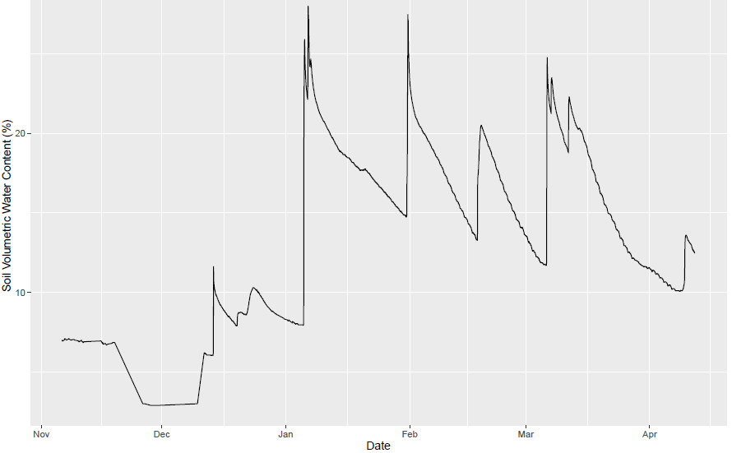
Figure 1: Mean daily transpiration VWC of A. fasciculatum (n=3).

Figure 2: Mean daily transpiration (ml H₂O/hr per cm² stand basal area) for stand of A. fasciculatum (n=15) normalized by basal area. Missing data is due to power outages.

References
Ashbacher, A. & Cleland, E., 2015. Native and exotic plant species show differential growth but similar functional trait responses to experimental rainfall. Ecosphere, 6(November), pp.1–14. Available at: http://www.esajournals.org/doi/abs/10.1890/ES15-00059.1.
Bush, S.E. et al., 2010. Calibration of thermal dissipation sap flow probes for ring- and diffuse-porous trees. Tree Physiology, 30(12), pp.1545–1554.
Chen, H.Y.H. & Brassard, B.W., 2013. Intrinsic and Extrinsic Controls of Fine Root Life Span. Critical Reviews in Plant Sciences, 32(December 2012), pp.151–161.
D’Antonio, C.M. & Vitousek, P.M., 1992. Biological Invasions by Exotic Grasses, the Grass/Fire Cycle, and Global Change. Annual Review of Ecology and Systematics, 23, pp.63–87.
Dickens, S.J.M. & Allen, E.B., 2014. Exotic plant invasion alters chaparral ecosystem resistance and resilience pre- and post-wildfire. Biological Invasions, 16(5), pp.1119–1130.
Drew, A.P. & Ledig, F.P., 1980. Episodic Growth and Relative Shoot : Root Balance in Loblolly Pine S e e d l i n g s. , pp.143–148.
Du, E. & Fang, J., 2014. Linking belowground and aboveground phenology in two boreal forests in Northeast China. Oecologia, 176(3), pp.883–892. Available at: http://link.springer.com/10.1007/s00442-014-3055-y.
Dunn, P.H. et al., 1988. The San Dimas Experimental Forest : 50 Yearsof Research,
Granier, a, 1987. Evaluation of transpiration in a Douglas-fir stand by means of sap flow measurements. Tree physiology, 3(4), pp.309–20. Available at: http://www.ncbi.nlm.nih.gov/pubmed/14975915.
Meng, R. et al., 2014. Remote sensing analysis of vegetation recovery following short-interval fires in Southern California Shrublands. PLoS ONE, 9(10), pp.14–17.
Ryel, R.J. et al., 2004. Water conservation in Artemisia tridentata through redistribution of precipitation. Oecologia, 141(2), pp.335–345.
Schenk, H. & Jackson, R., 2002. Rooting depths, lateral root spreads and below-ground/above-ground allometries of plants in water-limited ecosystems. Journal of Ecology, 90(3), pp.480–494. Available at: http://www.blackwell-synergy.com/doi/abs/10.1046/j.1365-2745.2002.00682.x.
Schwinning, S. & Ehleringer, J.R., 2001. Water use trade-offs and optimal adaptations to pulse-driven arid ecosystems. Journal of Ecology, 89(3), pp.464–480.
Smith, M.S. et al., 2014. Links between belowground and aboveground resource-related traits reveal species growth strategies that promote invasive advantages. PLoS ONE, 9(8), p.e104189.
Steinaker, D.F. & Wilson, S.D., 2008. Phenology of fine roots and leaves in forest and grassland. Journal of Ecology, 96(6), pp.1222–1229.
Steinaker, D.F., Wilson, S.D. & Peltzer, D. a., 2009. Asynchronicity in root and shoot phenology in grasses and woody plants. Global Change Biology, 16(8), pp.2241–2251. Available at: http://doi.wiley.com/10.1111/j.1365-2486.2009.02065.x.
Stylinski, C.D. & Allen, E.B., 1999. Lack of native species recovery following severe exotic disturbance in southern Californian shrublands. Journal of Applied Ecology, 36(4), pp.544–554.
Thornley, J.H.M., 1971. A Balanced Quantitative Model for Root . Shoot Ratios in Vegetative Plants. , pp.431–441.
Willis, C.G. et al., 2010. Favorable climate change response explains non-native species’ success in Thoreau's Woods. PLoS ONE, 5(1).
Wilson, S.D., 2014. Below-ground opportunities in vegetation science. Journal of Vegetation Science, 25, pp.1117–1125.

